Practice 1

1. List all directories from root directory.

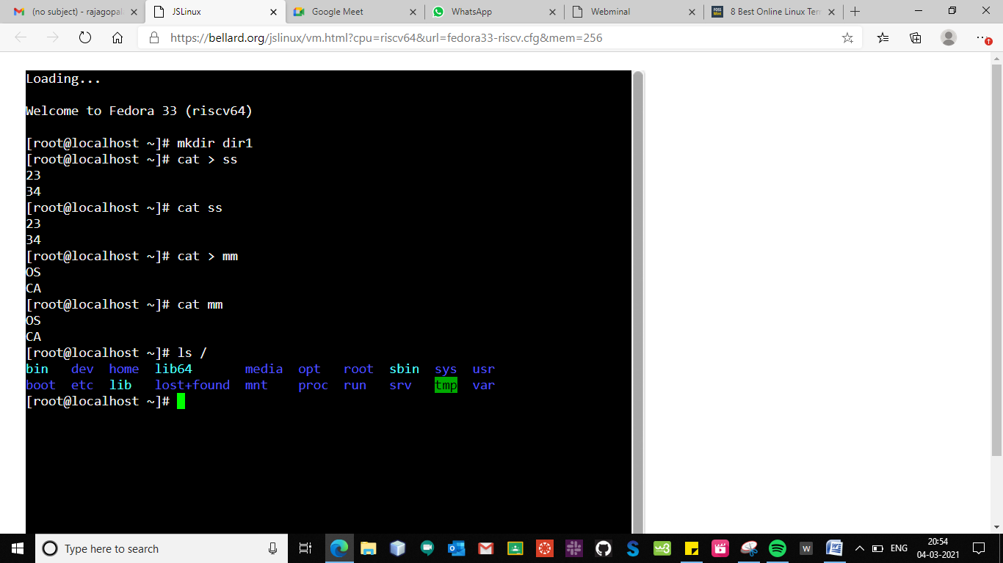

1. Login from normal user and create a directory. Access this directory from both paths.

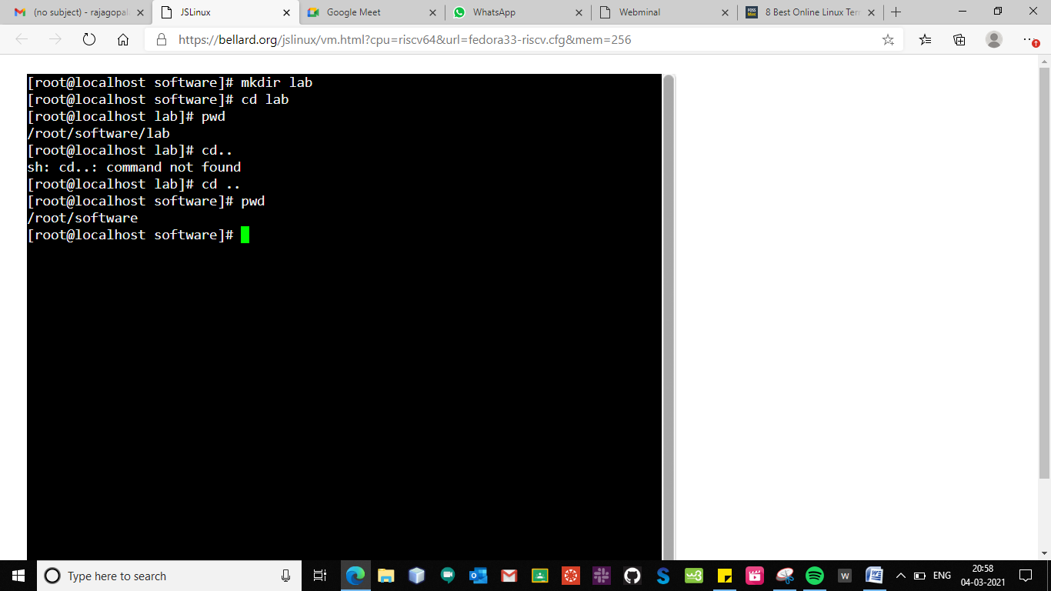

1. List the content from home directory and root directory. List the hidden files from home folder and find out the directory in which files are most recently modified.

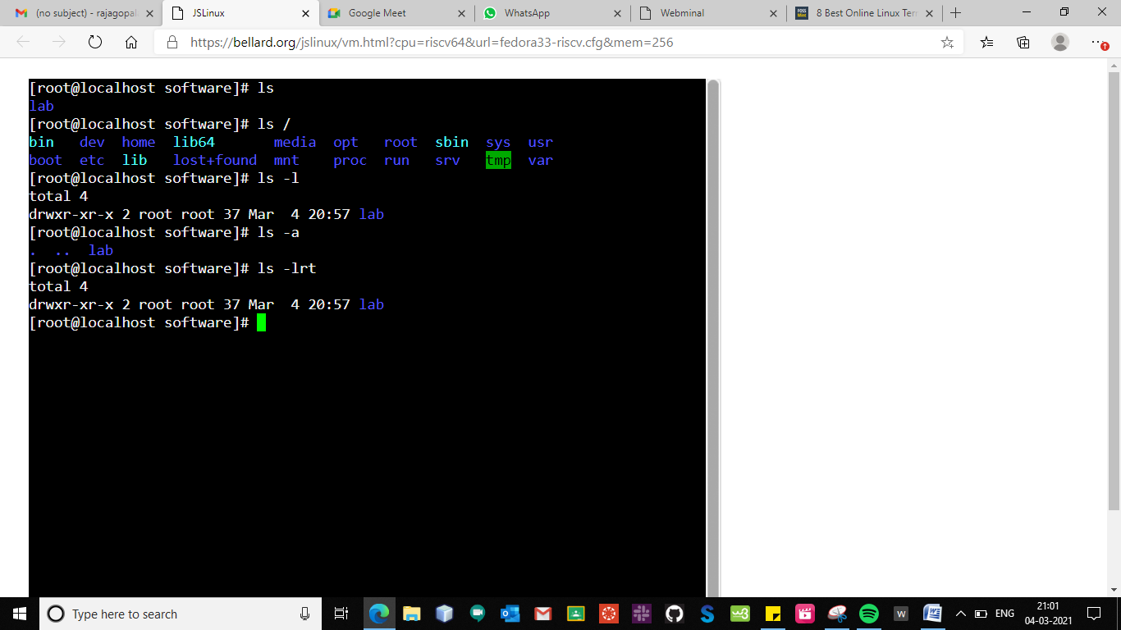

1. Create a test123 directory and move in it. Create blank files with following names:-test, test.doc, test.docx, test-file, test_file, test.file, test file (‘test file’ at command prompt), .test-file (hidden file)Verify the file creation. Verify the hidden file. Exit from directory and delete the directory.

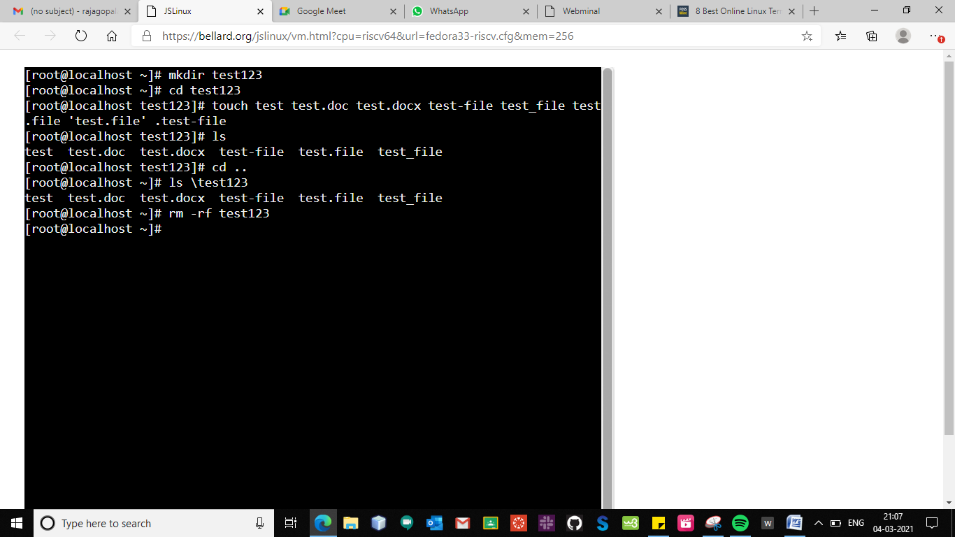

1. Login from normal user and create a test123 directory. Move in test123 directory and create 100 files. Use alphabet range (a – j) and numeric range (1- 10) for files name. Confirm files creation. Exit from directory. Create a new directory with mydirname. Copy files which starts with letter afrom test123 directory to mydirdirectory. Move the files which start with letter bfrom test123 directory to mydir. Confirm the copy and move action. Delete the files which end with letter 8. Confirm the action. Delete all files from test123 directory and delete the directory. Try to delete the mydirdirectory with rmdircommand. Delete the mydirdirectory and clear the screen.

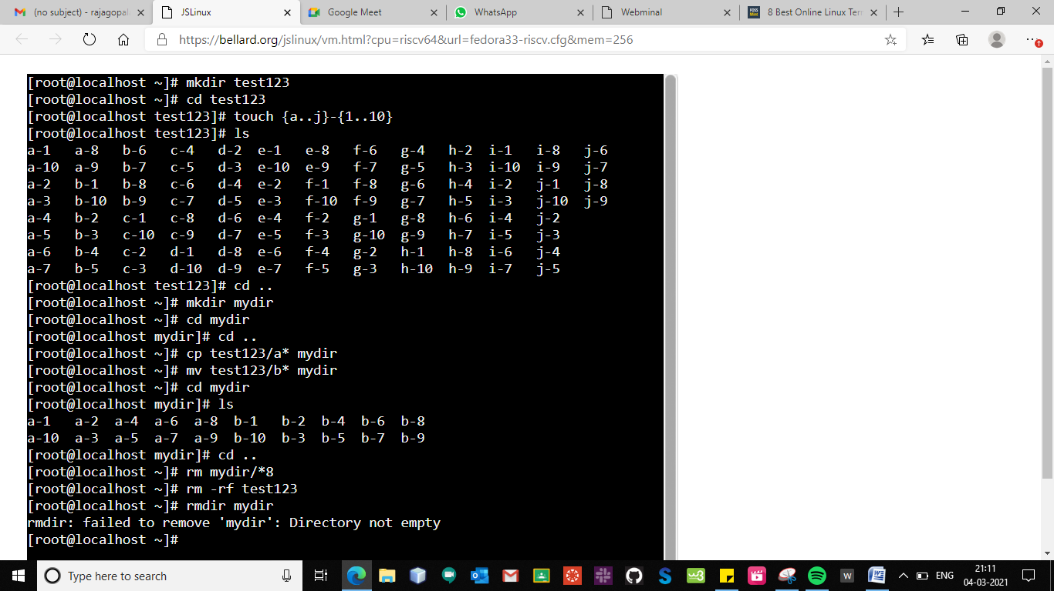

1. Sort the given file with respect to column 2

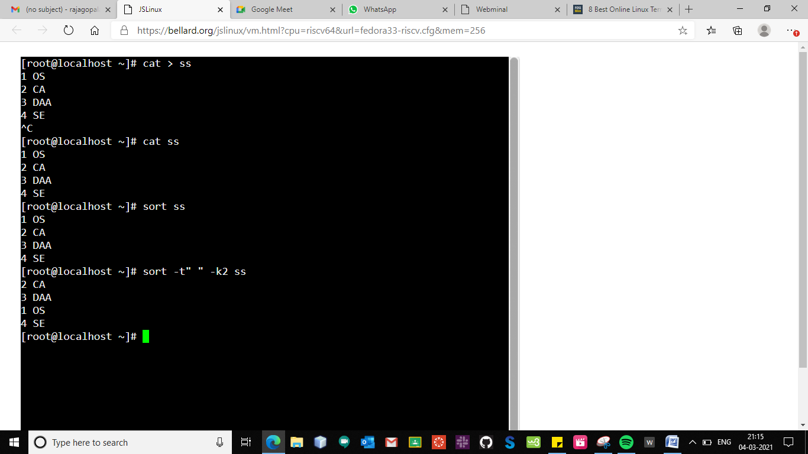

1. List all files by size with use of sort command.

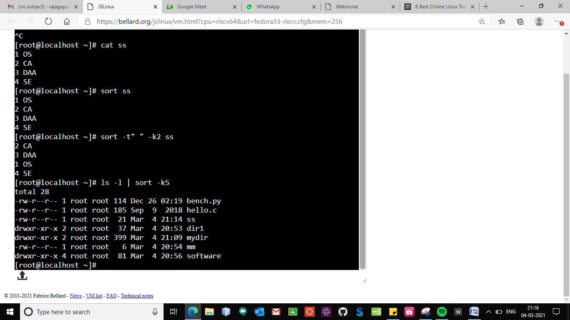

1. Store the number of txt file in the current working directory using tee command

